Application for ACT Tour
Asan Medical Center Interventional Cardiology Training Program Tour
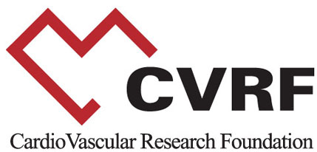

CardioVascular Research Foundation (CVRF)
2nd Floor, Asan Institute for Education & Research, 388-1, 88, Olympic-Ro 43-Gil, Songpa-Gu, Seoul 05505, Korea
Tel: 82-2-3010-7253 | Fax: 82-2-475-6898 | E-mail: program@summitMD.com | URL: www.cvrf.org

l. Personal Data

Full Name:
Last Name First Name Middle Name Initial

Date of Birth |  |  | Sex | Nationality | Specialty
Month | Day | Year | □ M □ F

Ⅱ. Contact Information

Present Organization
Telephone
E-mail (Mandatory)

Ⅲ. ACT Tour

Which tour would like to join?

Date | Section | Departure Time | Please Choose Possible Slots.
April 29 (Mon.) | Tour 1 | 10:00 AM
April 29 (Mon.) | Tour 2 | 2:00 PM

* Only TCTAP participants can register in this program.

