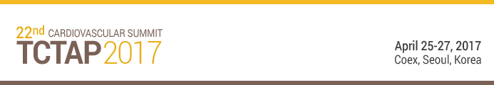

HOUSING REQUEST FORM

1. Guest Information
Type | Faculty | Attendee |  | Industry Professional |  |  |  |  |  |  Other :
 Ms.  Mr. | First Name: Last Name
Address
Address | Postal code |  |  |  |  | Country
Tel / Fax | Telephone |  |  |  |  | Fax
E-mail
Flight Information | Arrival Date |  | (MM/DD/YY) |  | Flight No.
Flight Information | Departure Date |  | (MM/DD/YY) |  | Flight No.
Check-in | (MM/DD/YY) |  |  |  | Check-out |  | (MM/DD/YY)
2. Credit Card Details
3. Hotel and Room Preference
Card Type |  Amex  Diners  Euro Card  JCB  Master  VISA | Name of the Cardholder
Card No.
Security Code | (Visa/Master: 3 digit numbers on the backside, Amex: 4 digit numbers on the front of the Card)
Exp. Date | / (MM/YY) |  | Signature
Hotel Name | Ramada Seoul Hotel
Room  Preference |  Double Bed  Twin Beds  Other ( )
Room  Preference |  Smoking  Non-smoking
* Special room rates are eligible only for the CARDIOVASCULAR SUMMIT-TCTAP attendees.
* Check-in time is 15:00 pm & Check-out is 12:00 pm. It may vary in accordance with each hotel's policy.
* For early check-in and late check-out, an extra charge would be added according to hotel regulations.
4. Guarantee & Cancellation Policy
* All policies can be kept updating according to hotel policies.
* At the time of booking, a credit card is required as a guarantee for your reservation
* In case of a NO SHOW of a guaranteed reservation the hotel reserves the right to levy retention charges for entire reserved stay.

