HOTEL RESERVATION REQUEST

Special rate for participants of TCTAP 2016 at COEX, Seoul, Korea,
25 April 2017 ~ 27 April 2017

♦ Please complete this form and return directly by fax or email to us no later than 10 days prior to your arrival to ensure room availability and special discount.

Reservation Dept.: Phone: +82 2 3466 7103, 7709 / Fax: +82 2 3466 7112,

Email: reservations.opcc@oakwoodpremier.co.kr or ricky@oakwoodpremier.co.kr

Arrival Date: | Flight No./ Time:
Departure Date: | Flight No./ Time:
Last Name(Mr./Ms.): | First Name:
Sharing Room with:
Company Name:
Phone No.: | Fax No.:
Email:
♦ Please circle your choice of accommodations:

Hotel | Room Type | Single Occupancy
Oakwood  Premier  Coex  Center | Studio Superior  (47SQ.M.)  Click see the room | □ KRW245,000
Oakwood  Premier  Coex  Center | Studio Premier  (58SQ.M.)  Click see the room | □ KRW270,000
Oakwood  Premier  Coex  Center | One Bedroom Superior (96SQ.M.)  Click see the room | □ KRW300,000
Oakwood  Premier  Coex  Center | Two Bedroom Superior  (114SQ.M)  Click see the room | □ KRW330,000

∗ Breakfast charge is KRW19,000++ in case of including in the room rate
∗ The all above special rates are subject to 21% service charge & tax.
∗ The above special rates are Complimentary Internet inclusive.
♦ A credit card number is required to guarantee your reservation.

Card: □ Amex □ Diners □ Master □ Visa □ JCB | 4 digit # for AMEX: _ _ _ _
Card Number: | Expiry Date:

∗ One night room payment inclusive of tax and service charge in case of no-show or
late cancellation made 7 days prior to check-in.
∗ Check-in time - 3:00 pm, Check-out time - 12:00 noon.

♦ Please indicate special requests and comments (Breakfast and Etc.);

Date: Signature:

Studio Superior
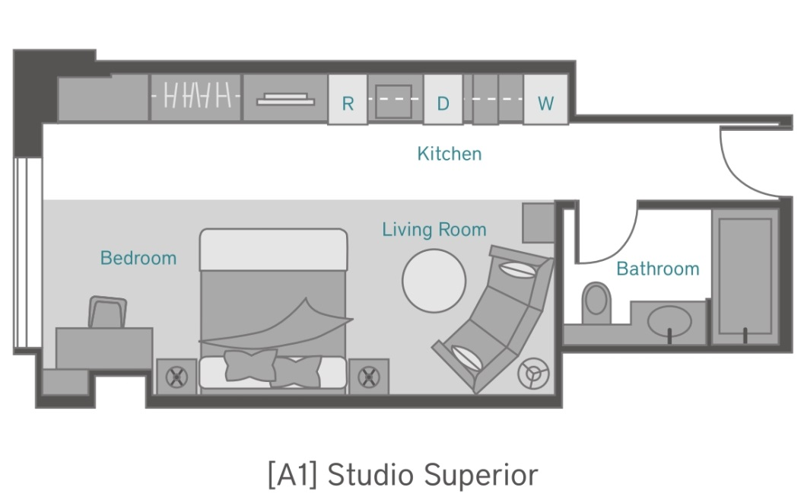
Studio Premier
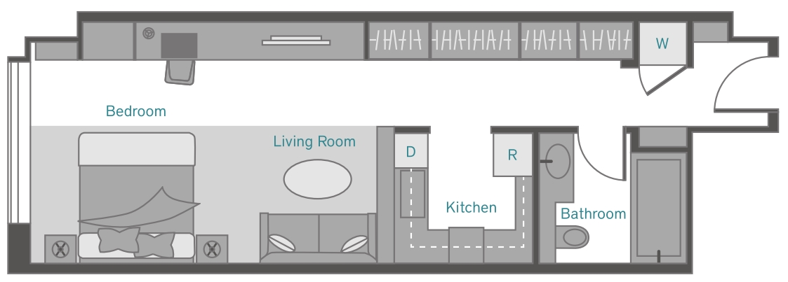
1 Bedroom Superior
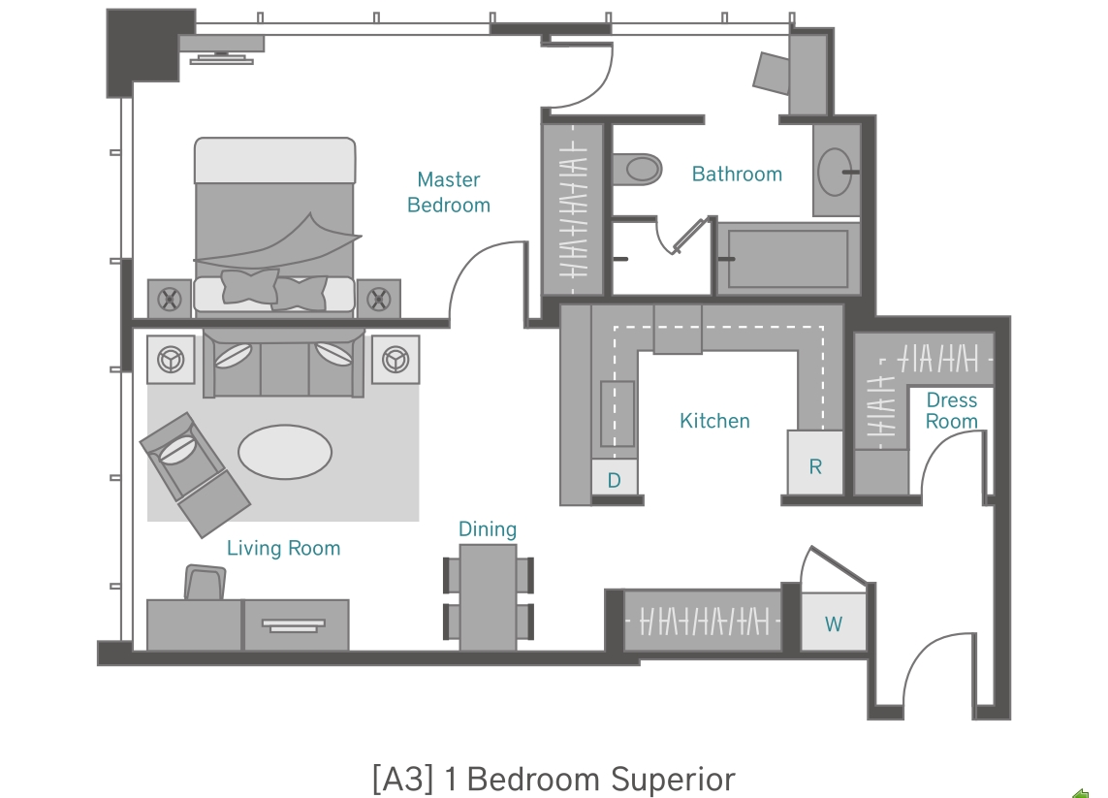

2 Bedroom Superior
