Application for ACT Tour
Asan Medical Center Interventional Cardiology Training Program Tour
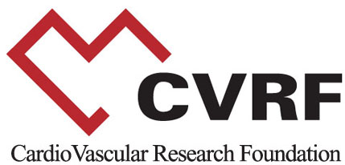

CardioVascular Research Foundation (CVRF)
2nd Floor, Asan Institute for Education & Research, 388-1, Poongnap-2dong, Songpa-gu, Seoul, 138-736, Korea
Tel: 82-2-3010-4792 | Fax: 82-2-475-6898 | E-mail: yuyun@summitMD.com | URL: www.cvrf.org

l. Personal Data

Full Name:
Last Name First Name Middle Name Initial

Date of Birth |  |  | Sex | Nationality | Specialty
Month | Day | Year | □ M □ F

Ⅱ. Contact Information

Present Organization
Mailing Address
Mailing Address | Zip Code
Telephone | Fax
E-mail (Mandatory)
Emergency Contact | Name Contact Number

Ⅲ. ACT Tour

Which tour would like to join?

Date | Section | Departure Time | Please Choose Possible Slots.
April 28(Wed.) | Tour 1 | 4:00 pm
April 29 (Thu.) | Tour 2 | 10:00 am
April 29 (Thu.) | Tour 3 | 4:00 pm

