HOUSING INFORMATION

1. MAP
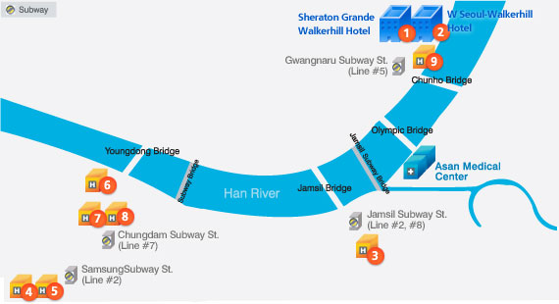

2. Special Room Rates and Contacts

 | Hotels | Room Rates &  Distance from the Venue | Contacts
1 | Sheraton Grande Walkerhill Hotel  ★★★★★ | Double/Twin: KRW 247,000 | Ms. Jennifer Yoon  T. 822-2022-0561 F. 822-2022-0567  E. jennifer.yoon@whotels.com www.walkerhill.co.kr  **Online Reservation:  www.starwoodmeeting.com/Book/TCTSHERATON  www.starwoodmeeting.com/Book/TCTW
2 | W Seoul Walkerhill Hotel  ★★★★★ | Double/Twin: KRW 280,000
3 | Lotte Hotel Jamsil  ★★★★★ | Double/Twin: KRW 180,000  15 minutes drive | Mr. Kyung-tae Doo  T. 822-411-7533 F. 822-414-6698  E. ktdoo@hotellotte.co.kr  www.lottehotel.co.kr
4 | Grand InterContinental Seoul  ★★★★★ | Double/Twin: KRW 200,000  25 minutes drive | Ms. Julie Lim  T. 822-559-7766 F. 822-559-7996  E. sjlim@icseoul.co.kr  www.seoul.intercontinental.com  *Double occupancy charge of KRW 20,000 will be applied.
5 | COEX InterContinental Seoul  ★★★★★ | Double/Twin: KRW 180,000  25 minutes drive
6 | Hotel ELLUI  ★★★★ | Double: KRW 120,000  20 minutes drive | Mr. Woon-tae Jeong  T. 822-514-3535 F. 822-516-6145  E. annres@ellui.com www.ellui.com
7 | Hotel Prima  ★★★★ | Double: KRW 120,000  Deluxe Double: KRW 140,000  Deluxe Twin: KRW 140,000  20 minutes drive | Mr. Dong-Ri Lim  T. 822-6006-9307 F. 822-6006-9310  E. victor727@hanmail.net www.prima.co.kr
8 | Hotel Riviera  ★★★★ | Double/Twin: KRW 100,000  20 minutes drive | Mr. Tae-sang Kwon  T. 822-3438-4541 F. 822-3438-4209  E. kwonts@hotelriviera.co.kr  www.hotelriviera.co.kr
9 | HanKang Hotel  ★★★ | Double/Twin: KRW 90,000  5 minutes drive | Mr. Dae-up Park  T. 822-453-5131 F. 822-453-5130  E. hankang@hankanghotel.co.kr  www.hankanghotel.co.kr

HOUSING REQUEST FORM

√ How to Reserve
• Fax this form or mail it DIRECTRLY to Hotels of your preference. The confirmations will be given by email.
• Online reservation is available (only for Walkerhill Hotels) at www.starwoodmeeting.com/Book/TCTSHERATON
√ Housing Policy
• Room requests will be processed for only those who registered to the Angioplasty Summit-TCT Asia Pacific 2009.
• Rooms must be guaranteed with a credit card and this form must be completed in full before room requests.
• The details are referred to the Hotel’s terms and condition.

1. Guest Information

 Ms. |  Mr. | First Name: Middle Name: Last Name:
Advance Registration Number |  |  |  | Summit09__ __ __ __ - __ __ __ __
Address
 |  | Zip code |  |  | Country
Tel / Fax |  | Telephone |  |  | Fax
E-mail
2. Payment Guarantee
Card Type |  Amex  Diners  Euro Card   JCB  Master  VISA | Card Holder’s Name
Card Type |  Amex  Diners  Euro Card   JCB  Master  VISA | Pin Number/CVC Code
Exp. Date | __ __ / __ __ (MM/YY) | Signature
Card No. | __ __ __ __ __ __ __ __ __ __ __ __ __ __ __ __ | Signature
3. Hotel and Room Preference
Check-in | Date: __ __ / __ __ / __ __ (MM/DD/YY) |  | Check-out | Date: __ __ / __ __ / __ __ (MM/DD/YY)
Hotel Choice | *Please refer to the Housing Information |  | Room Type |  Double  Twin
Hotel Choice |  |  | Room Type |  Smoking  Non Smoking
Special Comments to Hotel


Secretariat of Angioplasty Summit-TCT Asia Pacific 2009
CardioVascular Research Foundation (CVRF)
2nd Floor, Asan Institute for Education & Research, 388-1, Poongnap-2dong, Songpa-gu, Seoul, 138-736, Korea
Tel: 82-2-3010-4720 | Fax: 82-2-475-6898 | E-mail: cvrf@summitMD.com | URL: www.summit-tctap.com

